Lab Report 1

ESE – 3005

EMBEDDED SYSTEMS ARCHITECTURE 2

Submitted to :

Linchan Wang

Submitted by:

Gurvinder Singh(748418)

Environment for poky

1.cd poky

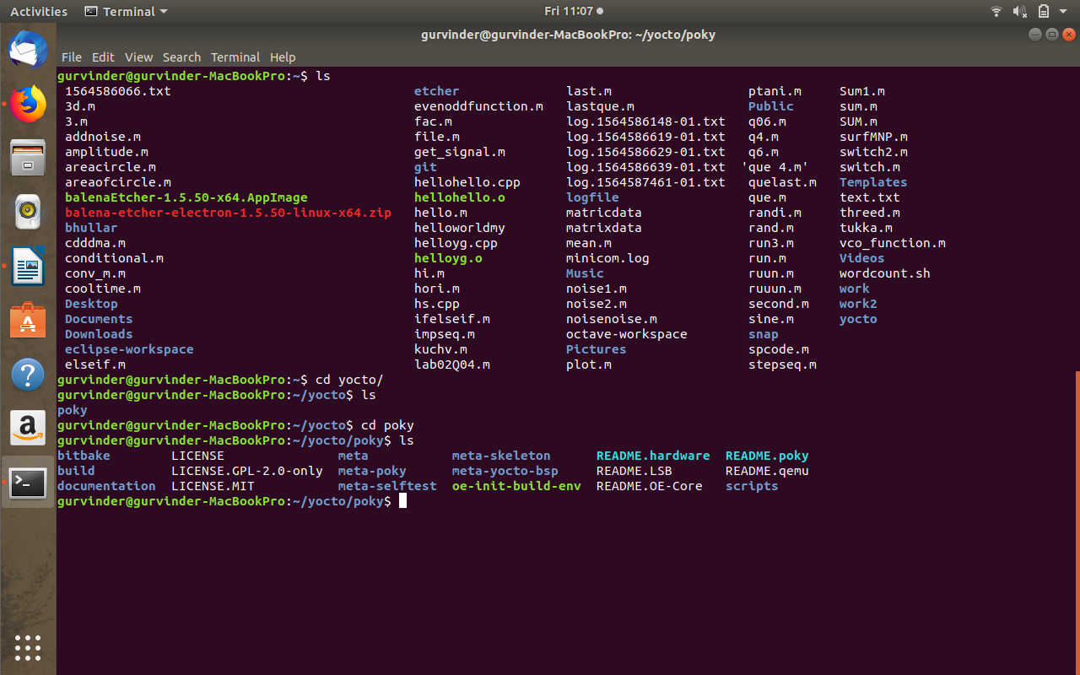

2. cd build

3. cd config

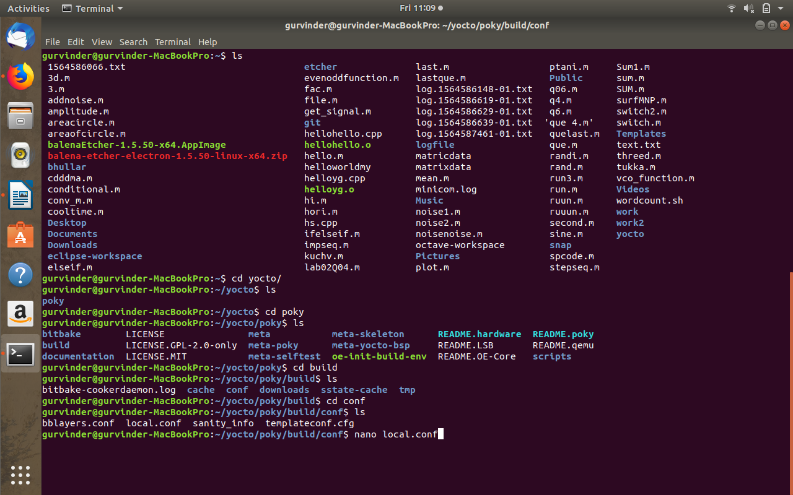

4. nano local.conf

5. Removal of #

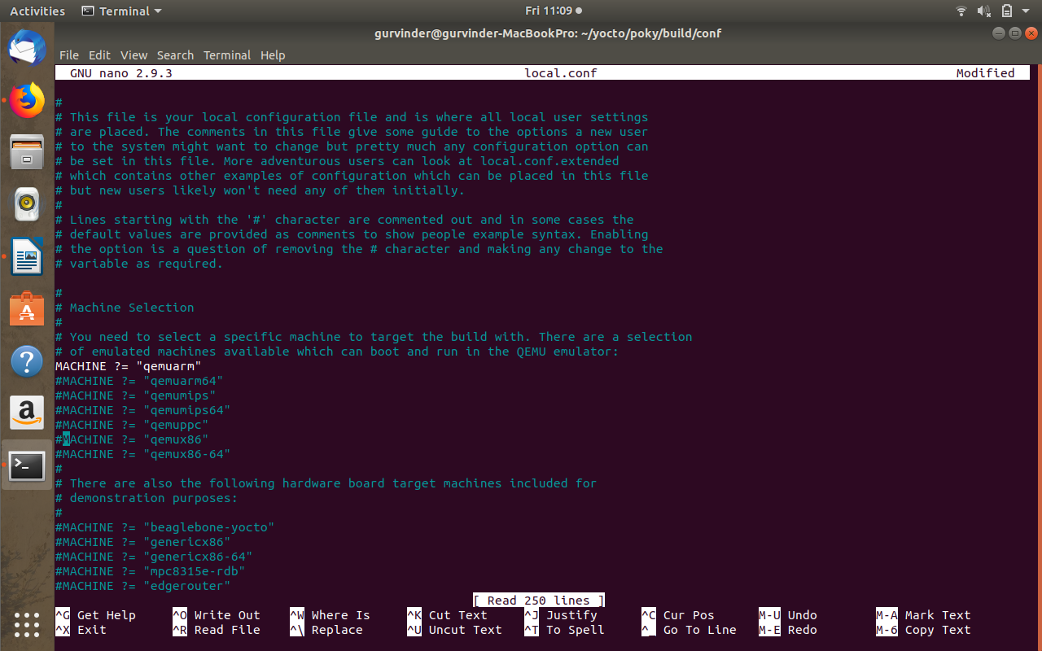

6. run ./oe-init-build-env

